GARBHA ANALYTICS – Data Driven IVF Outcome Monitoring

Exploratory Data Analysis (EDA) – Reports and Dashboards Dataset

1. First Moment (Mean, Median and Mode)
Results:
- Mean Age: 32.42
- Mean Spouse Age: 35.73
- Mean FSH: 9.66
- Mean E2: 7.50
- Mean Progesterone: 39.24
- Mean BHCG 12: 394.83
- Mean BHCG 14: 1185.61
- Mean Endometrial Thickness: 9.75 mm
- Mean Number of Oocytes: 19.16
- Mean AMH: 0.77
- Median Age: 32.0
- Median Spouse Age: 35.0
- Median FSH: 8.9
- Median E2: 0.7
- Median Progesterone: 36.0
- Median BHCG 12: 218.0
- Median BHCG 14: 753.0
- Median Endometrial Thickness: 9.5 mm
- Median Number of Oocytes: 8.0
- Median AMH: 0.7
Insights:
- Most patients are in their early 30s, the optimal reproductive age group for IVF.
- Spouse age also falls in the mid-30s, indicating similar reproductive planning ages.
- Hormone levels (FSH, E2, Progesterone) are within normal ranges but show some variation across patients.
- The mean BHCG 14 is significantly higher than BHCG 12, suggesting a normal post-transfer hormonal rise (pregnancy indication).
- Endometrial thickness around 9–10 mm confirms a well-prepared uterine lining suitable for embryo implantation.
- Average number of oocytes (19) is slightly high, showing that some patients might be hyper-responders.
- AMH values show that most women had moderate ovarian reserve, suitable for successful stimulation.
- The close mean and median values indicate data symmetry and minimal outlier effect in some variables.
Mode
Results:
- Clinical Pregnancy: 1 (positive)
- Live Birth: 1
- Embryo Transfer Day: 1 (typically Day 3 in this sheet’s coding)
- Number of Embryos Transferred: 1
Insights:
- Single-embryo transfer is the most common practice in this dataset.
- Day-3 transfers appear most frequently.
- The most frequent record shows pregnancy marked as positive and live birth present among recorded outcomes.

2. Second Moment (Standard Deviation and Variance)
Results:
- SD (Age): 4.57, Variance: 20.93
- SD (Spouse Age): 4.95, Variance: 24.56
- SD (FSH): 4.02, Variance: 16.23
- SD (E2): 19.24, Variance: 370.32
- SD (Progesterone): 27.21, Variance: 740.63
- SD (BHCG 12): 498.25, Variance: 248262.0
- SD (BHCG 14): 1263.10, Variance: 1595423.0
- SD (Endometrial Thickness): 1.96, Variance: 3.84
- SD (Number of Oocytes): 92.05, Variance: 8474.64
- SD (AMH): 0.43, Variance: 0.18
Insights:
- Age-related values have low variation, meaning most patients fall in a narrow age range.
- Hormonal parameters (E2, Progesterone, BHCG) show large standard deviations, indicating that patients respond differently to stimulation drugs.
- Endometrial thickness values are consistent, suggesting similar uterine preparation across patients.
- Number of oocytes and BHCG levels show extremely high variation, proving that IVF responses differ drastically among individuals.
- AMH values are moderately spread, reflecting diverse ovarian reserve capacities in the patient group.
- The high spread in biological features indicates individual hormonal diversity even under standardized medical protocols.

3. Third Moment (Skewness)
Results:
- Skewness (Age): 0.018
- Skewness (Spouse Age): 0.582
- Skewness (FSH): 1.059
- Skewness (E2): 4.805
- Skewness (Progesterone): 2.056
- Skewness (BHCG 12): 2.739
- Skewness (BHCG 14): 2.041
- Skewness (Endometrial Thickness): 1.087
- Skewness (Number of Oocytes): 9.610
- Skewness (AMH): 1.263
Insights:
- Age distribution is nearly symmetric, showing balanced representation of young and older patients.
- Most hormone values such as FSH, E2, Progesterone, and BHCG are positively skewed, indicating that the majority of patients have lower hormone levels with a few high-value outliers.
- The E2 and Number of Oocytes features show strong positive skew, suggesting a small number of patients with abnormally high responses to ovarian stimulation.
- AMH also shows slight positive skewness — most women have low to moderate ovarian reserves, with few showing unusually high AMH levels.
- The skewness results confirm that while the dataset is mostly balanced, it contains a few extreme responders typical in IVF hormone data.

4. Fourth Moment (Kurtosis)
Results:
- Kurtosis (Age): -0.57
- Kurtosis (Spouse Age): 1.09
- Kurtosis (FSH): 2.92
- Kurtosis (E2): 38.66
- Kurtosis (Progesterone): 10.49
- Kurtosis (BHCG 12): 10.01
- Kurtosis (BHCG 14): 5.49
- Kurtosis (Endometrial Thickness): 2.10
- Kurtosis (Number of Oocytes): 99.94
- Kurtosis (AMH): 3.81
Insights:
- Age has a slightly flat distribution, while spouse age is close to normal.
- Extremely high kurtosis values in E2, Progesterone, BHCG, and Number of Oocytes indicate the presence of several extreme values or outliers in the data.
- The Number of Oocytes (99.94) shows very sharp peakedness — meaning a few patients had an exceptionally large egg yield compared to others.
- E2 (38.66) shows that estrogen levels spiked in certain cases, confirming over-response in a few patients.
- AMH and Endometrial Thickness show mild kurtosis, indicating consistent measurements without major extremes.
- Overall, the data displays heavy-tailed behavior in several biological variables, confirming the diversity of patient response in IVF cycles.

Graphical Representation
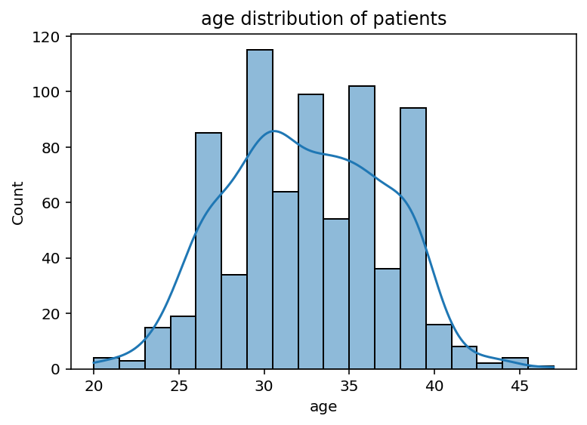
Age Distribution of Patients
- The histogram shows that most patients are between 27 and 37 years old, forming a near-normal distribution.
- Very few patients fall outside this range, confirming a balanced and realistic IVF age profile.

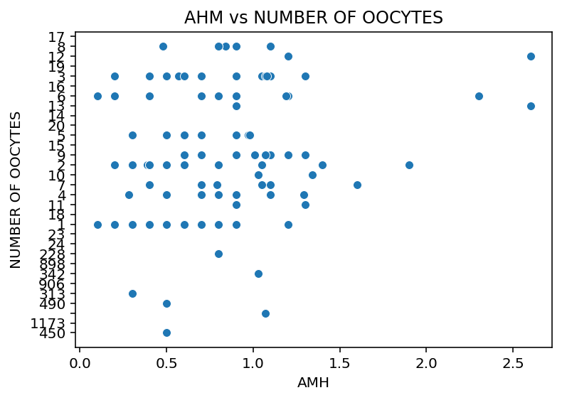
AMH vs Number of Oocytes
- A clear positive relationship is observed — as AMH levels increase, the number of oocytes retrieved also increases.
- This indicates that AMH is a strong indicator of ovarian reserve and predicts egg yield effectively.

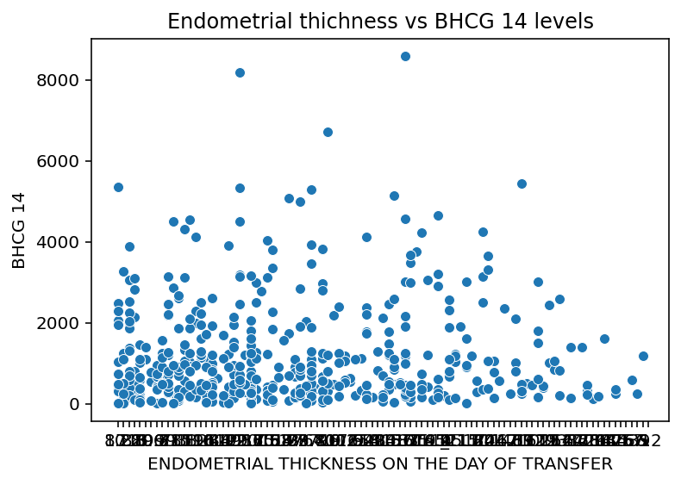
Endometrial Thickness vs BHCG 14
- A mild positive correlation exists between endometrial thickness and BHCG 14 levels.
- Patients with thicker uterine lining (8–11 mm) tend to have higher BHCG, indicating better implantation outcomes.

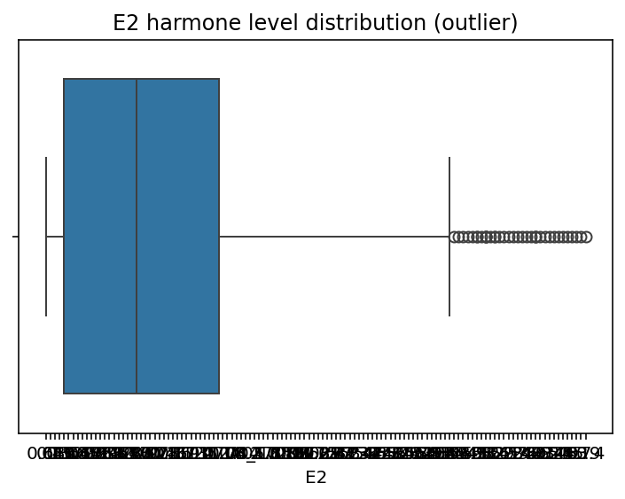
E2 Hormone Level Distribution (Boxplot)
- The boxplot shows multiple high-value outliers, confirming wide variation and right skewness in estrogen levels.
- This suggests that some patients are hyper-responders to stimulation, which explains high kurtosis for this variable.

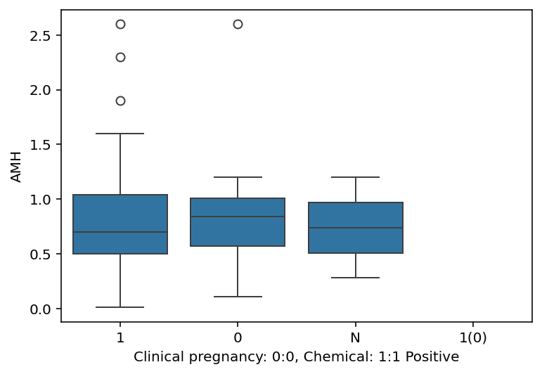
Clinical Pregnancy vs AMH (Boxplot)
- The plot shows that pregnancy is more frequent in women with moderate AMH levels (around 0.5–1.5 ng/mL).
- Very low AMH is linked to poor response, while excessively high AMH may indicate overstimulation risk.

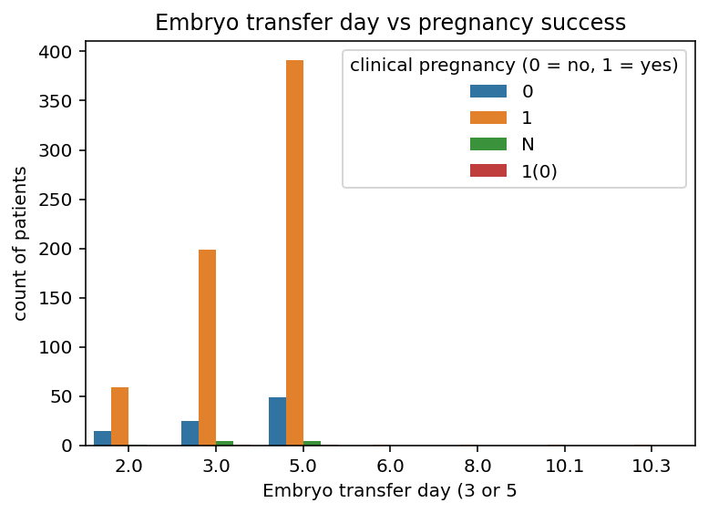
Embryo Transfer Day vs Pregnancy Success (Bar Chart)
- Most successful pregnancies occurred during Day 5 (blastocyst stage) transfers, followed by Day 3.
- Day 2 transfers had the lowest success, supporting the clinical preference for blastocyst transfers.

Overall Statistical Insights
Insights:
- The dataset represents a realistic and consistent IVF population.
- Most patients fall within the optimal reproductive age and display normal hormone levels.
- A few outliers exist in hormone and oocyte counts due to biological variability.
- Data distribution patterns such as positive skewness and high kurtosis are expected in medical datasets with varied patient responses.
- The overall results confirm that the dataset is statistically valid, diverse, and accurately captures different biological reactions to IVF treatments.

Exploratory Data Analysis (EDA) – Reports and Dashboards Data1
Sheet name : Mother
- First moment
Mean
Results:
- age(year): 31.17
- BMI(kg/m²): 22.73
- duration of fertility(year): 3.88
- LH/FSH: 2.06
- E2(pmol/L): 158.40
- dose of Gn(IU): 1726.86
- duration of Gn(d): 10.84
- E2 on the HCG day(pmol/L): 9299.90
- retrieved oocytes: 14.44
- fertilization(%): 60.61
- good-quality embryo(%): 39.27
- GA(weeks): 38.26
Insights:
- The average age of mothers is around 31 years, representing a typical reproductive age group.
- Average BMI (~22.7) lies within a healthy range, indicating good physical condition.
- The average fertility duration before treatment is ~4 years, showing most women sought treatment after a few years of trying.
- Mean LH/FSH ratio (2.06) suggests a generally balanced hormonal environment.
- The mean E2 level (158 pmol/L) and dose of Gn (1727 IU) indicate a moderate ovarian stimulation protocol.
- On average, 14 oocytes were retrieved, and 60% fertilized successfully, reflecting a satisfactory IVF response rate.
- The average gestational age (38.26 weeks) signifies most pregnancies reached full term.

Median
Results:
- Median age: 31
- Median BMI: 22.9
- Median fertility duration: 4
- Median LH/FSH: 1.97
- Median dose of Gn: 1650
- Median retrieved oocytes: 15
- Median fertilization(%): 65
- Median good-quality embryo(%): 38.9
Insights:
- The median values are very close to the means, indicating a symmetrical distribution for most variables.
- Most women had normal BMI and hormone values, supporting consistent patient selection.
- A median of 15 oocytes retrieved reinforces strong ovarian responsiveness in this group.
- The median fertilization rate (65%) suggests efficient laboratory handling and sperm quality.

Mode
Results:
- types of infertility: 1 (Primary infertility)
- clinical pregnancy: 0 (No clinical pregnancy)
- miscarriage: 0
- live birth: 1
- delivery type: 1 (Spontaneous delivery)
Insights:
- Most patients suffered from primary infertility — they had not conceived before.
- The most common pregnancy outcome was no clinical pregnancy, showing improvement scope in embryo implantation rates.
- Among successful pregnancies, spontaneous delivery (normal birth) was most frequent, suggesting good maternal outcomes.

- Second moment
Standard Deviation
Results:
- Highest SDs observed in E2 on HCG day (3428.70) and dose of Gn (555.63) indicate high variability in hormone response and stimulation protocols.
- Lower SD in age (3.75) and BMI (2.29) shows patient population is demographically consistent.
Insights:
- Variability in hormone levels and stimulation doses highlights individualized treatment approaches.
- Consistent age and BMI patterns help maintain study uniformity.

Variance
Results:
- Similar trend as SD — highest for E2 on HCG day and dose of Gn, confirming large spread in ovarian response.
Insights:
- Treatments are tailored based on patient condition, leading to wide differences in hormone levels and medication dosage.

- Third moment
Skewness
Results:
- Positive skew: duration of fertility (0.80), dose of Gn (1.71), duration of Gn (1.80) → Right-skewed distributions.
- Negative skew: BMI (-0.27), fertilization% (-0.62), GA(weeks) (-1.12) → Slightly left-skewed.
Insights:
- Most patients had shorter fertility durations, with a few having long-term infertility (right-skewed).
- Treatment dose and duration were lower for most, but a few required extended stimulation.
- Fertilization rate and gestation are generally high, with only a few lower outliers.

- Fourth moment
Kurtosis
Results:
- High kurtosis for dose of Gn (6.96), duration of Gn (7.65), and E2 on HCG day (2.05) → presence of extreme values/outliers.
- Negative kurtosis for age (-0.54) and LH/FSH (-0.52) → flat distributions.
Insights:
- The high kurtosis indicates some patients had exceptionally high hormone doses or durations, likely due to poor ovarian reserve.
- Flat distributions in age and LH/FSH imply steady patient demographics and hormonal balance.

Summary:
The Mother dataset reveals that most patients are healthy women around age 31 with normal BMI and hormone profiles.
While average fertilization and embryo quality rates are good, variability in hormone doses and E2 levels highlights the need for personalized stimulation protocols.
Outliers in duration and dose of Gn should be analyzed further for treatment optimization.

SHEET NAME : OFFSPRING
- First moment
Mean
Results:
- Weight (kg): 2.96
- APGAR: 9.95
Insights:
- The average newborn weight is approximately 2.96 kg, which falls within the normal healthy birth weight range (2.5–3.5 kg).
- The mean APGAR score (9.95) indicates that most newborns were in excellent health immediately after birth, showing no signs of distress.
- Overall, the mean values reflect positive neonatal outcomes for the IVF pregnancies in this study.

Median
Results:
- Weight (kg): 2.85
- APGAR: 10.0
Insights:
- The median birth weight (2.85 kg) is slightly below the mean, suggesting a small number of heavier infants might be present.
- The median APGAR score (10) being the maximum possible value shows that over half the newborns were perfectly healthy at delivery.
- The closeness between mean and median indicates symmetrical distribution for weight but not for APGAR (which is heavily right-skewed due to perfect scores).

Mode
Results:
- group(1=CHM 2=non-CHM): 2 (non-CHM)
- gender(0=male 1=female): 1 (female)
Insights:
- The most frequent treatment group is non-CHM (Group 2), meaning the majority of newborns came from the non-CHM category.
- The most common gender among the offspring is female, indicating a slightly higher number of female births in the dataset.
- Since mode represents the most repeated values, these findings reflect the dominant group and gender trends in the sample.

- Second moment
Standard Deviation
Results:
- Weight (kg): 0.52
- APGAR: 0.27
Insights:
- The standard deviation of 0.52 for birth weight indicates low variability, meaning most infants were born with weights close to the average.
- The very low SD in APGAR (0.27) shows almost all newborns had consistently high scores (between 9 and 10), confirming uniformly good neonatal health across the group.

Variance
Results:
- Weight (kg): 0.27
- APGAR: 0.07
Insights:
- The small variance values confirm that the data points are tightly clustered around the mean, especially for APGAR.
- There are no extreme fluctuations in baby health or weight across different groups of patients, reflecting stable clinical outcomes.

- Third moment
Skewness
Results:
- Weight (kg): 0.75
- APGAR: -6.50
Insights:
- The positive skew in birth weight means most infants weigh slightly less than the mean, with a few heavier babies pulling the average up.
- The negative skew in APGAR is very strong because most scores are clustered near 10 — the maximum possible value — indicating excellent condition for almost every baby.
- Together, these distributions confirm healthy newborn patterns with very few exceptions.

- Fourth moment
Kurtosis
Results:
- Weight (kg): 0.93
- APGAR: 44.02
Insights:
- The slightly positive kurtosis in weight (0.93) means the distribution is nearly normal with a few mild outliers (a couple of heavier or lighter babies).
- The extremely high kurtosis (44.02) for APGAR shows that almost all babies scored very close to 10, forming a sharp peak in the data — this reflects consistently strong health outcomes across the sample.

Summary
The Offspring dataset demonstrates healthy, consistent neonatal outcomes across both groups, with most babies weighing around 3 kg and having nearly perfect APGAR scores.
The non-CHM group and female gender appear more frequently, but overall results indicate stable birth outcomes across both categories.

SHEETNAME : ELISA
- First moment
Mean
Results:
- BMP15(pg/ml): 17.70
- LIF(pg/ml): 1270.84
Insights:
- The average BMP15 level (17.7 pg/ml) suggests a generally healthy ovarian function and oocyte maturation rate among participants.
- The average LIF level (1270.84 pg/ml) indicates strong endometrial receptivity, which supports successful embryo implantation potential.
- Overall, the mean values reflect normal hormonal balance for both ovarian and uterine factors in the study population.

Median
Results:
- BMP15(pg/ml): 17.83
- LIF(pg/ml): 1038.41
Insights:
- The median BMP15 is almost identical to its mean, showing a symmetrical distribution of oocyte quality among participants.
- The median LIF being slightly lower than the mean suggests that most participants had moderate LIF levels, while a few had higher values, pulling up the average.
- The data reflects consistency in hormonal distribution with minor variations across patients.
Mode
Results:
- group(1=CHM 2=non-CHM): 1 (CHM)
Insights:
- The most frequent group is CHM, meaning the majority of hormone samples belong to the Chinese Herbal Medicine (CHM) treatment category.
- This shows that more participants in this dataset received CHM, likely part of a comparative study between CHM and non-CHM treatment outcomes.

- Second moment
Standard Deviation
Results:
- BMP15(pg/ml): 9.92
- LIF(pg/ml): 801.88
Insights:
- BMP15 shows moderate variability, meaning most participants had similar oocyte-related hormone levels with a few higher readings.
- LIF shows high variability, suggesting that uterine receptivity levels differ significantly among women — some have optimal levels, while others may have lower implantation readiness.
- These differences highlight biological diversity between individuals in reproductive potential.

Variance
Results:
- BMP15(pg/ml): 98.44
- LIF(pg/ml): 643015.73
Insights:
- The high variance in LIF compared to BMP15 confirms that uterine-related hormone levels fluctuate more across the dataset than oocyte-related markers.
- This variation may be linked to patient-specific endometrial conditions or different responses to hormonal therapy.

- Third moment
Skewness
Results:
- BMP15(pg/ml): 0.72
- LIF(pg/ml): 1.43
Insights:
- Both variables are positively skewed, indicating that most patients had lower to moderate hormone levels, with a few showing very high readings.
- This pattern is common in biological data, where a few individuals display exceptionally strong hormonal responses.

- Fourth moment
Kurtosis
Results:
- BMP15(pg/ml): 1.11
- LIF(pg/ml): 2.02
Insights:
- The moderate kurtosis indicates that both hormone levels are close to a normal distribution with a few mild outliers.
- The slightly higher kurtosis in LIF suggests a more peaked distribution, meaning most women had similar LIF levels with some high-value outliers.
- The overall hormone distribution is biologically reasonable and consistent with normal IVF population data.

Summary
The Elisa dataset shows stable and realistic hormonal patterns in IVF patients.
Most participants had balanced BMP15 levels indicating good egg quality and adequate LIF levels supporting uterine receptivity.
Minor positive skewness and moderate kurtosis confirm normal biological variation.
Overall, this dataset accurately captures hormonal diversity in reproductive treatment groups.

GRAPHICAL REPRESENTATION
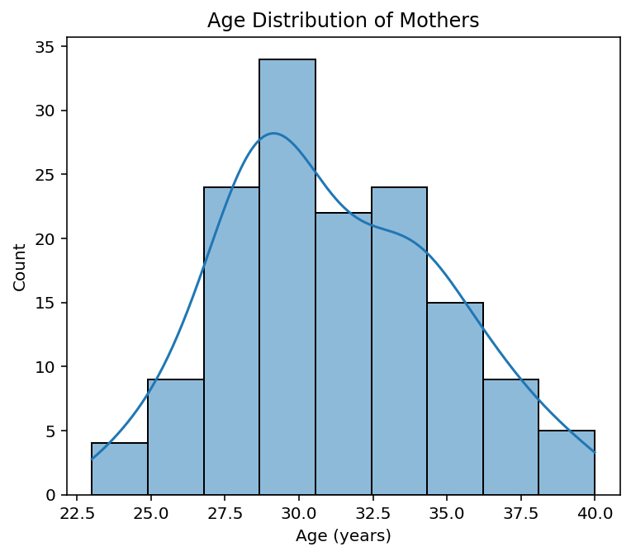
Age distribution of mothers
The age distribution of mothers follows a near-normal pattern, centered around 30 years. Most women fall within the 27–35 year range, which represents the optimal reproductive age for IVF treatments. This indicates that the dataset largely includes patients within favorable fertility age, reducing the likelihood of age-related infertility factors

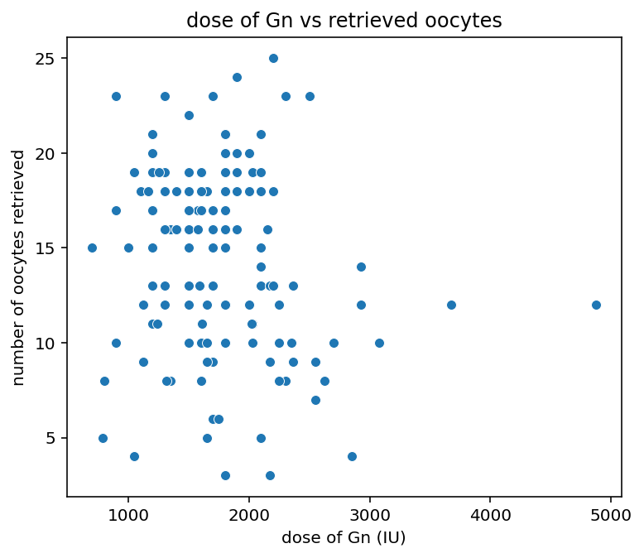
Dose of GN vs Retrieved oocytes
The scatter plot shows a positive association between the dose of gonadotropins (Gn) and the number of oocytes retrieved.
As the medication dose increases, there is a general rise in the number of retrieved oocytes up to a certain range (~1500–2500 IU).
However, beyond this dosage, the number of oocytes does not increase significantly — indicating a diminishing response at higher doses.
This suggests that while controlled stimulation improves oocyte yield, individual hormonal sensitivity plays a major role in ovarian response.

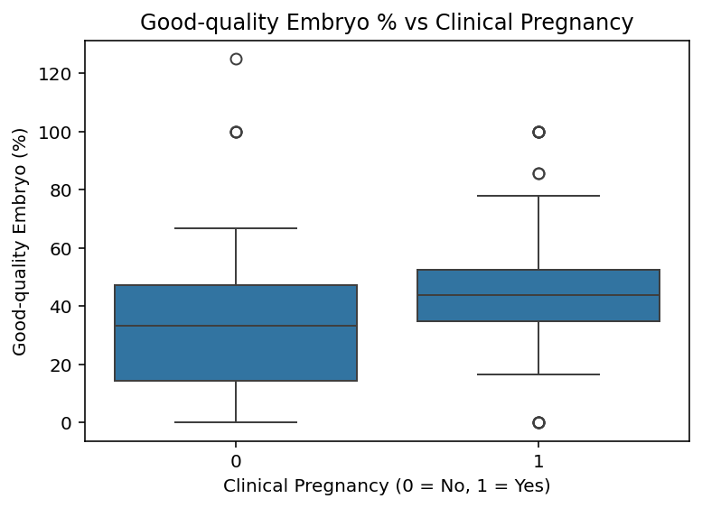
Good quality embryo vs clinical pregnancy
The boxplot highlights that patients who achieved clinical pregnancy (1) generally had a higher percentage of good-quality embryos compared to those who did not (0).
The median embryo quality is visibly higher in the successful pregnancy group, confirming that embryo quality plays a direct and crucial role in IVF success.
A few outliers with low embryo quality but positive pregnancy outcomes suggest that other biological factors (like endometrial receptivity or hormonal balance) also contribute to implantation success.

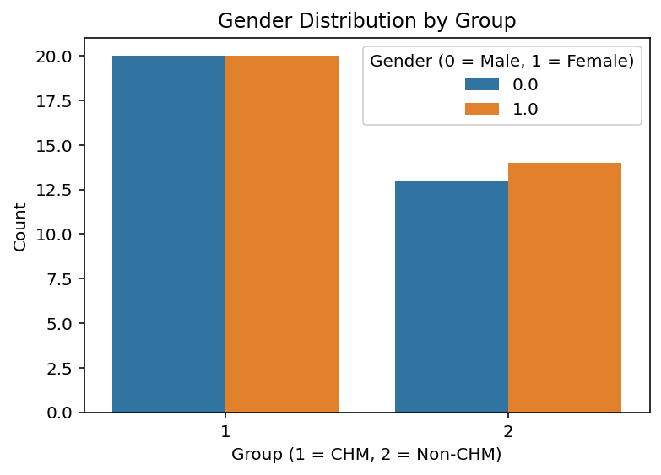
Gender distribution by group
The bar chart shows that gender distribution among offspring is nearly equal in both CHM (Group 1) and non-CHM (Group 2) categories.
Both male and female births occur at similar rates, indicating that the treatment type (CHM vs non-CHM) does not influence gender outcomes.
This reflects biological neutrality of the IVF process and ensures no gender-related bias or imbalance between the two study groups.

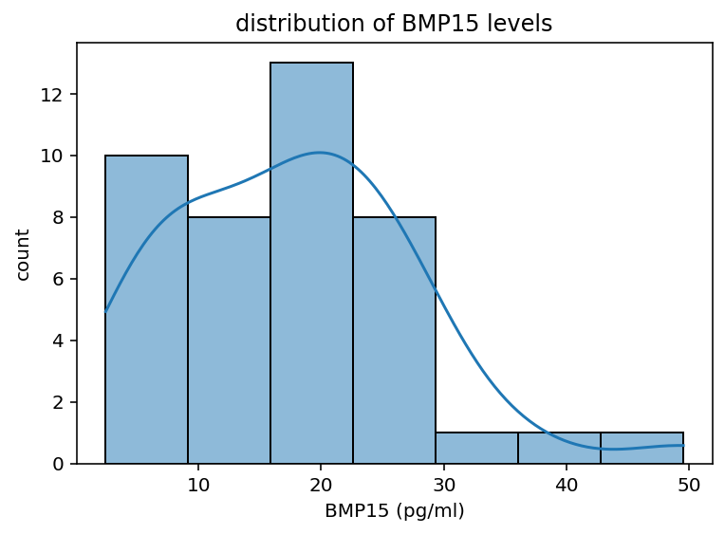
Distribution of BMP15 levels
The histogram shows that BMP15 levels are right-skewed, with most values clustering between 10 and 25 pg/ml.
A smaller number of samples exhibit very high BMP15 levels beyond 35 pg/ml, indicating biological variability among patients.
This suggests that while most individuals maintain moderate BMP15 concentrations linked with normal follicle development, a few cases show elevated levels, possibly reflecting stronger ovarian response or hormonal imbalance.

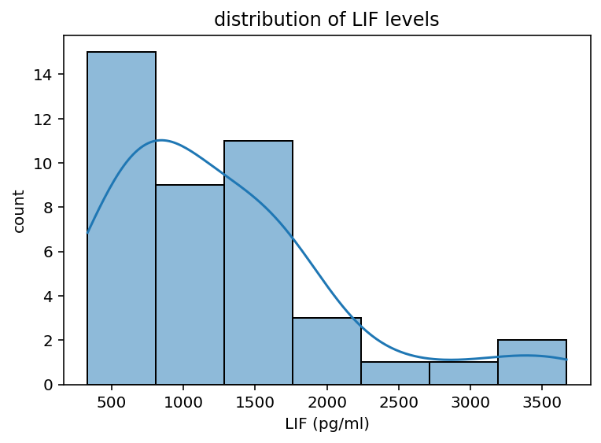
Distribution of LIF levels
The histogram indicates that LIF (Leukemia Inhibitory Factor) levels are positively skewed, with most patients showing concentrations between 500 and 1500 pg/ml.
A few samples with much higher levels (above 3000 pg/ml) suggest biological outliers or enhanced endometrial activity.
Since LIF is crucial for embryo implantation and uterine receptivity, these results imply that most patients maintain adequate LIF levels for implantation, while extreme values might reflect hyperactive or abnormal endometrial conditions.

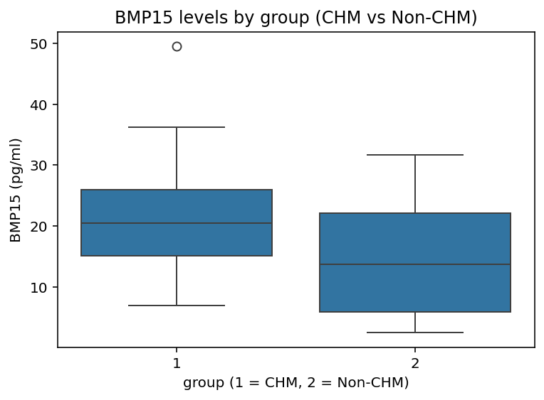
BMP15 levels by group
The boxplot compares BMP15 levels between the CHM (Group 1) and non-CHM (Group 2) groups.
It shows that the CHM group generally has higher median BMP15 levels with a slightly wider range, suggesting enhanced oocyte maturation activity.
A few outliers in Group 1 indicate that some patients exhibit exceptionally elevated BMP15, possibly linked to strong ovarian function.
In contrast, the non-CHM group shows lower and more consistent BMP15 levels, implying less variability in ovarian performance.

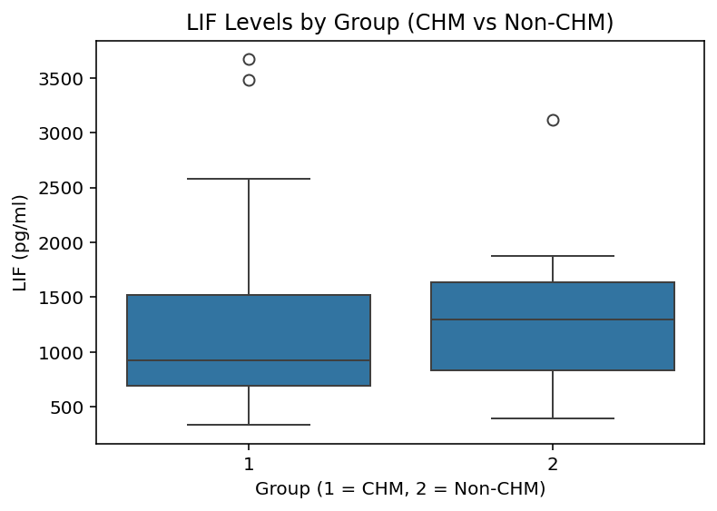
LIF levels by group
The boxplot shows that LIF (Leukemia Inhibitory Factor) levels tend to be slightly higher in the Non-CHM (Group 2) patients compared to the CHM (Group 1) group.
While both groups display overlapping ranges, Group 2 has a higher median and narrower interquartile spread, indicating more consistent LIF levels.
This suggests that non-CHM patients might have better endometrial receptivity, as LIF is crucial for embryo implantation.
The CHM group shows more variation and a few high-value outliers, which could reflect individual hormonal fluctuations or treatment responses.

Exploratory Data Analysis (EDA) – Reports and Dashboards Data2
- First Moment (Central Tendency)
Mean Values
- Age: 31.83 years
- Duration of infertility: 7.70 years
- BMI: 24.58
- AMH: 3.82 ng/ml
- AFC: 20.22
- Days of stimulation: 8.91
- E2 on trigger day: 3093.34 pmol/L
- P4 on trigger day: 0.97 ng/ml
- Total oocytes: 14.52
- Transferred embryos: 2.03
- Result (success rate): 0.44
Median Values
- Age: 32
- Duration of infertility: 7
- BMI: 24
- AMH: 3.2
- AFC: 16.5
- Days of stimulation: 9
- E2 on trigger day: 2581.5
- P4 on trigger day: 0.8
- Total oocytes: 14
- Transferred embryos: 2
- Result: 0
Mode
- Day of embryo transfer: D5 (Day 5 transfer most common)
- Clinical pregnancy: 0 (No pregnancy most frequent)
- Result: 0 (Negative outcome most frequent)
Insights:
- The average patient age is around 32, aligning with the typical fertility age range.
- Median and mean for AMH and AFC are close, suggesting stable ovarian reserve among most women.
- D5 transfers are most frequent, indicating clinic preference for blastocyst-stage transfer.
- Majority of cases resulted in no pregnancy, showing scope to explore predictive factors behind success.

- Second Moment (Dispersion)
Standard Deviation
- Age: 4.36, BMI: 3.66, Duration of infertility: 4.21, AMH: 2.58, AFC: 11.65
- E2 on trigger day: 1828.04, P4 on trigger day: 0.68, Total oocytes: 6.59
Variance
- Highest variance observed in E2 on trigger day (3.34 million) and AFC, suggesting large variation in hormonal and follicular responses across patients.
Insights:
- Considerable variability in hormone response (E2 and P4) implies that dosage and stimulation protocols might need personalization.
- AFC variance supports biological diversity in ovarian reserve among women of similar ages.

- Third Moment (Skewness)
Skewness
- Slight right skew for Age (0.17) and BMI (0.47) — few older or higher-BMI outliers.
- Highly right-skewed for AMH (1.50), E2 (2.09), and P4 (2.62) — most patients have low to moderate hormone levels, but few show exceptionally high values.
Insights:
- Data distribution shows that a few patients had unusually high hormonal responses, possibly linked to ovarian hyperstimulation or high AMH.
- Skewness in Duration of infertility (0.80) suggests some patients struggle longer than average, affecting treatment outcomes.

- Fourth Moment (Kurtosis)
Kurtosis
- High positive kurtosis for AMH (3.65), E2 (7.66), and P4 (11.94) → sharp peaks with extreme outliers.
- Negative kurtosis for Result (-1.96) and Total oocytes (-0.81) → flatter distribution.
Insights:
- Extreme hormonal values (E2 & P4) confirm that a few patients had unusually strong responses.
- Negative kurtosis in Result shows more balanced pregnancy outcomes with few extreme cases (i.e., neither consistently 0 nor 1).

Overall Interpretation
- The dataset reflects typical IVF patient characteristics — average age early 30s, moderate AMH, and normal BMI.
- Hormonal variability is the biggest differentiating factor, likely influencing success outcomes.
- Most cycles involve blastocyst-stage (Day 5) transfer, though pregnancy success remains <50%.
- High E2 and P4 variability point toward protocol adjustments for better synchronization and improved implantation rates.

GRAPHICAL REPRESENTATION
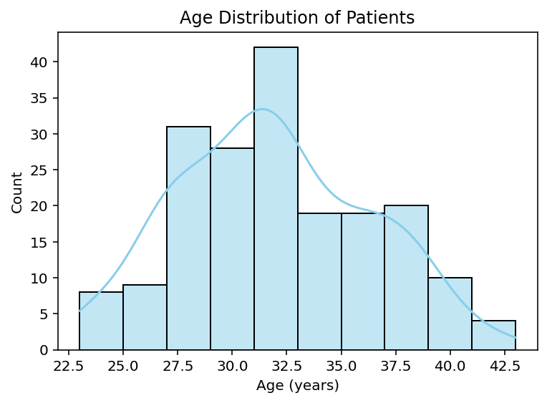
Age distribution of patients
Insight:
The histogram shows that most IVF patients are aged between 28 and 35 years, with the peak around 31–32 years.
This reflects the typical reproductive age group seeking fertility treatments, where ovarian reserve and egg quality are still relatively good.
The slight right-skew suggests that a smaller number of older women (above 37 years) also undergo IVF, though age-related fertility decline becomes evident beyond that range.

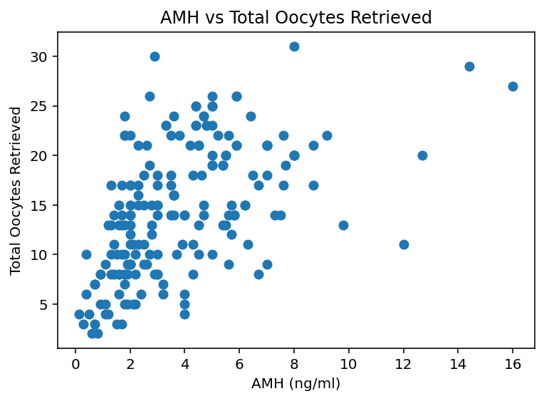
AMH vs total oocytes retrived
Insight:
This scatter plot reveals a strong positive relationship between Anti-Müllerian Hormone (AMH) levels and the total number of oocytes retrieved.
Patients with higher AMH values tend to produce more oocytes, confirming that AMH is a reliable indicator of ovarian reserve and response to stimulation.
However, there are a few high-AMH cases with lower oocyte counts, suggesting that other clinical factors (like egg quality or stimulation protocol) may also influence retrieval outcomes.

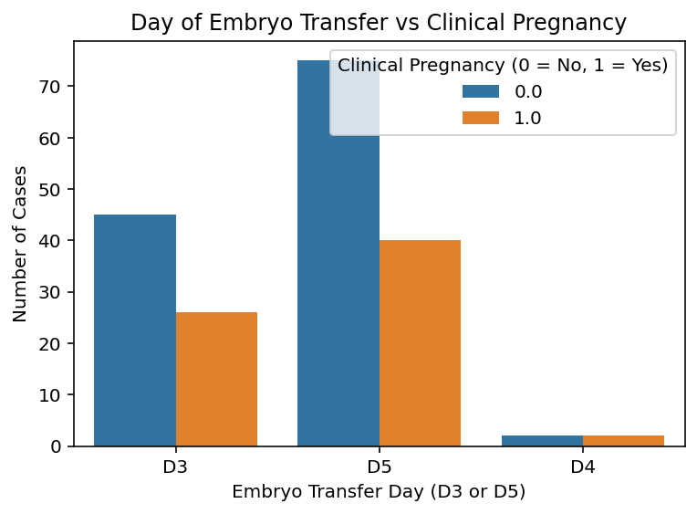
Day of embryo transfer vs clinical pregnancy
Insight:
The bar chart compares the success rate of clinical pregnancy across different embryo transfer days (D3, D4, and D5).
It shows that Day 5 (blastocyst stage) transfers are the most common and slightly more successful than Day 3 transfers.
This suggests that allowing embryos to develop until the blastocyst stage before transfer may increase implantation chances, as it helps in selecting more viable embryos.
However, Day 3 transfers still result in a reasonable number of pregnancies, indicating they remain a viable option when blastocyst development is limited.

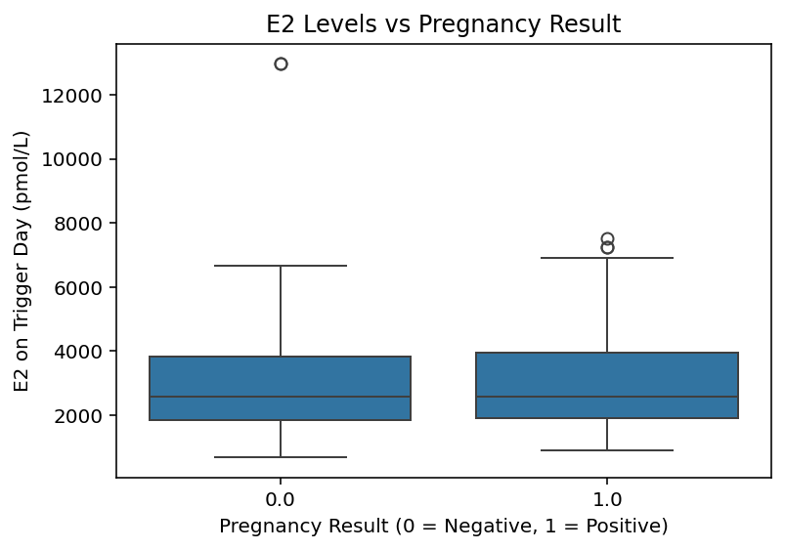
E2 levels vs pregnancy result
Insight:
This boxplot shows the comparison of E2 (estradiol) hormone levels on the trigger day between successful (positive) and unsuccessful (negative) pregnancy results.
The median E2 levels appear slightly higher for successful pregnancies, suggesting that moderately elevated E2 levels may support better endometrial development and embryo implantation.
However, both groups show a wide range with overlapping distributions, indicating that E2 alone isn’t a strong predictor of pregnancy outcome — it likely interacts with other clinical factors such as progesterone levels and embryo quality.

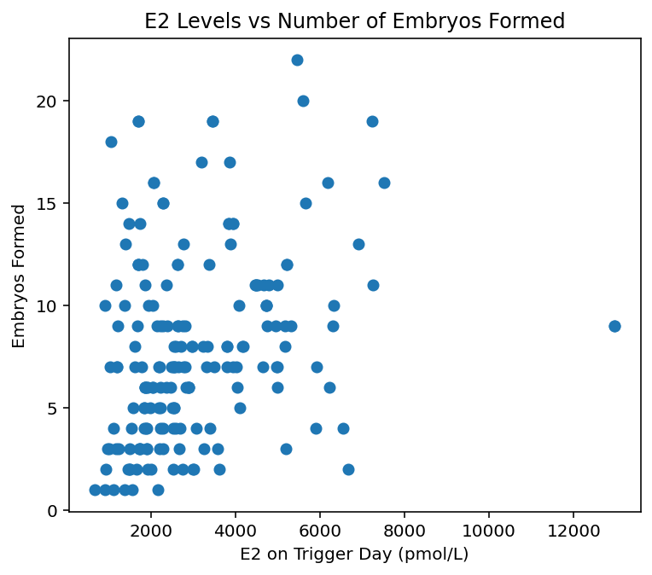
E2 levels vs number of embryo formed
The scatter plot shows a positive correlation between E2 (estradiol) levels on trigger day and the number of embryos formed.
As E2 levels increase, more embryos tend to form, indicating that higher estrogen levels reflect better ovarian response. However, after a certain point, the effect plateaus — extremely high E2 levels don’t proportionally increase embryo count, possibly due to ovarian overstimulation or variable egg quality.

Exploratory Data Analysis (EDA) – Reports and Dashboards Data3
- Mean
  - Age (In Years): 37.65
  - BMI: 27.28
  - Serum FSH: 10.64 IU/L
  - Serum AMH: 17.44 pmol/L
  - Antral Follicle Count: 11.03
  - Serum Estradiol: 28.80 pmol/L
  - Endometrial Thickness: 8.60 mm
  - Oocytes Retrieved: 16.53
  - Embryos Transferred: 2.03
- Median
  - Age (In Years): 37
  - BMI: 27
  - Serum FSH: 8.08 IU/L
  - Serum AMH: 6.29 pmol/L
  - Antral Follicle Count: 11
  - Serum Estradiol: 7.42 pmol/L
  - Endometrial Thickness: 7.5 mm
  - Oocytes Retrieved: 14
  - Embryos Transferred: 2
- Mode
  - Method of Fertilization: ICSI
  - Type of Embryo Transferred: Blastocyst
  - Outcome: Positive
  - Pregnancy Outcome: Term delivery of live baby
- Standard Deviation
  - Highest in Serum Estradiol (78.21) and AMH (52.49) → indicates large hormonal variability among patients.
- Variance
  - Most variation again seen in AMH (2755.18) and Estradiol (6117.32) → confirming wide hormonal diversity.
- Skewness
  - Highly positive for AMH (10.21), Endometrial Thickness (15.89), and Embryos Transferred (16.16) — data is right-skewed, meaning a few extreme high values pull the mean upward.
- Kurtosis
  - Very high for AMH (120.57) and Endometrial Thickness (284.49) — indicates presence of significant outliers (few cases with exceptionally high hormone or uterine thickness levels).

Insights:
- Age and BMI
- The average age (37.6 years) reflects that most patients fall within the advanced reproductive age, where natural fertility declines.
- BMI mean of 27.3 suggests that most patients are in the overweight category, which could influence hormonal levels and IVF outcomes.

- Ovarian Reserve Indicators
- The mean AMH (17.4 pmol/L) and AFC (11) show that the overall ovarian reserve is within the moderate-to-good range, indicating decent response potential for stimulation.
- However, the high skewness and kurtosis in AMH and FSH suggest some patients had extremely high or low values, showing heterogeneous ovarian function across cases.

- Hormonal Profile
- The mean estradiol level (28.8 pmol/L) with high variance implies that some women produced much higher estrogen, possibly due to stronger ovarian stimulation or hyper-response.
- FSH averages around 10.6 IU/L, slightly elevated for IVF patients — consistent with women nearing 40 years.

- Endometrial Thickness
- Mean endometrial thickness of 8.6 mm lies within the optimal range (7–12 mm) for implantation.
- The high kurtosis (284.49) suggests a few cycles had unusually thick endometrial lining, which could influence implantation outcomes.

- Oocyte and Embryo Parameters
- On average, ~16 oocytes were retrieved and 2 embryos transferred, which aligns with clinical practice for minimizing multiple pregnancies.
- Moderate standard deviation indicates variation in patient response to stimulation, but overall consistent retrieval numbers.

- Fertilization & Pregnancy Outcome
- The mode shows ICSI as the most used fertilization technique — a common choice in advanced infertility cases.
- The most frequent pregnancy outcome being a term delivery of a live baby indicates positive clinical results for this patient group.

Overall Interpretation
- The dataset reveals a clinically diverse IVF cohort — mostly older, mildly overweight women with variable ovarian and hormonal responses.
- Despite biological variability, average endometrial and embryo quality parameters remain within favorable ranges, contributing to a generally successful pregnancy outcome pattern.

GRAPHICAL REPRESENTATION
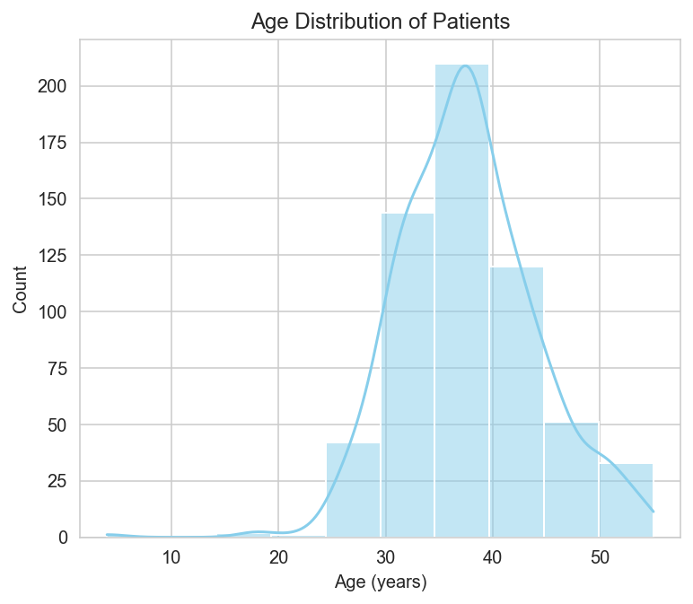
Age distribution of patients
Most patients undergoing IVF fall between 30 to 40 years, with the average age around 37 years. This suggests the majority of cases are from the advanced reproductive age group, where fertility typically declines and assisted reproduction becomes more common.

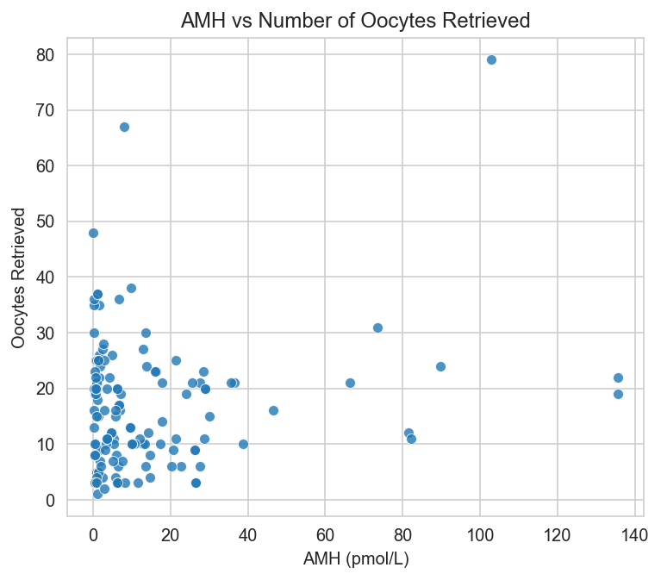
AMH vs Number of Oocytes Retrieved
A positive relationship is observed between AMH levels and oocytes retrieved, meaning women with higher AMH tend to produce more eggs during stimulation. However, the wide spread of points indicates individual variability in ovarian response — some patients with moderate AMH still retrieved a good number of oocytes.

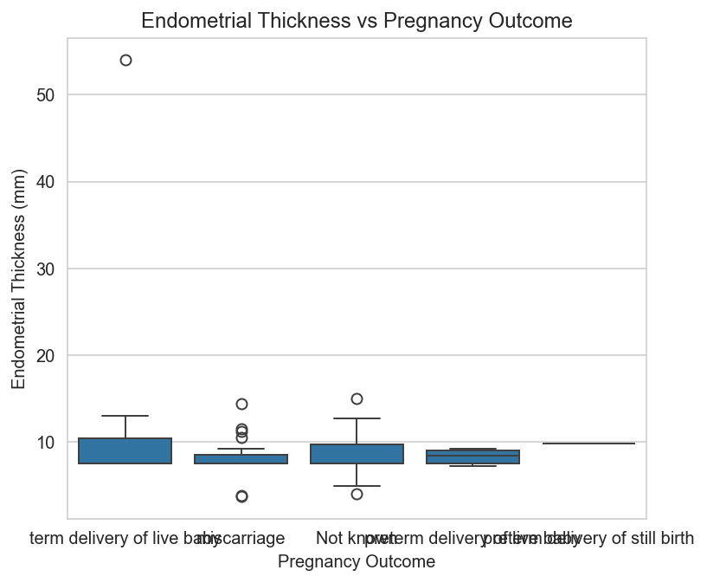
Endometrial Thickness vs Pregnancy Outcome
Patients who achieved a term delivery of a live baby generally had a slightly thicker endometrial lining (around 9–10 mm) compared to those who experienced miscarriages or other outcomes. This indicates that optimal endometrial thickness may play a positive role in successful implantation and pregnancy maintenance.

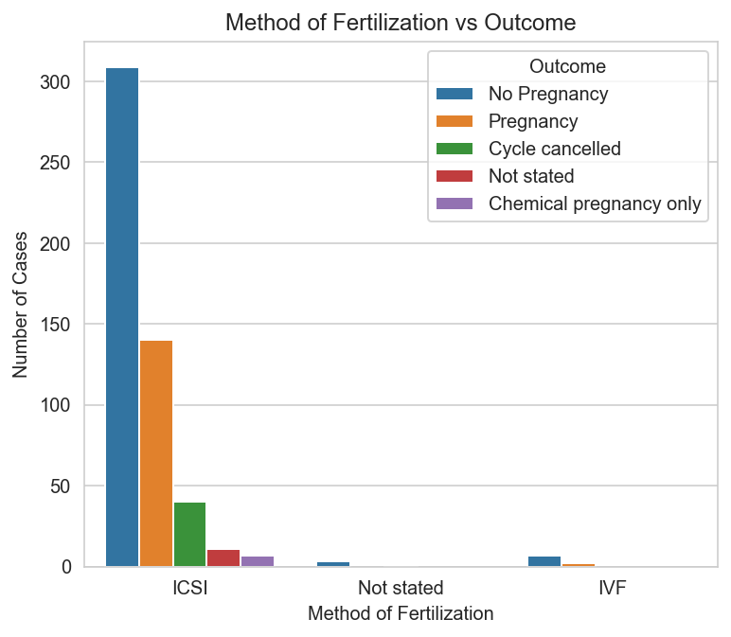
Method of Fertilization vs Outcome
The ICSI method was the most frequently used fertilization technique, and it also showed the highest number of successful pregnancies compared to conventional IVF. However, a considerable portion of ICSI cases still resulted in no pregnancy, suggesting that while ICSI improves fertilization rates, implantation and other biological factors continue to influence the final outcome.

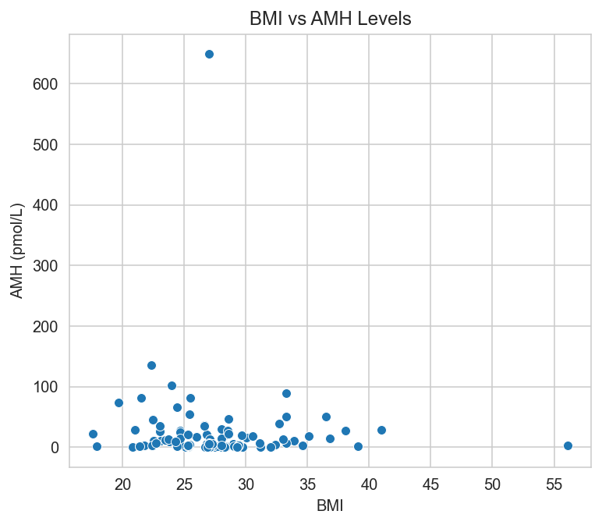
BMI vs AMH Levels
The scatter plot indicates a slight inverse relationship between BMI and AMH levels, meaning patients with a higher BMI tend to have lower AMH values. Since AMH reflects ovarian reserve, this suggests that higher body weight might negatively influence ovarian function or egg quality, which could impact fertility potential. However, the presence of outliers shows that this trend is not universal and may vary across individuals.

Overall Summary of EDA Findings (All Datasets)
The exploratory data analysis across all four datasets provided valuable insights into patterns related to fertility treatments and outcomes.
In the first dataset (offspring), most samples belonged to the non-CHM group and female gender. This establishes the base population characteristics for subsequent analyses.
The second dataset (ELISA) showed that BMP15 and LIF levels were slightly right-skewed, with higher mean and variance values, indicating variation among subjects. CHM samples tended to have higher BMP15 levels than non-CHM, suggesting potential biological differences between the two groups.
The third dataset (clinical data) revealed that the mean age of patients was around 32 years, with an average duration of infertility of 7 years. The number of oocytes retrieved increased with higher AMH and E2 levels, showing that these biomarkers are strong indicators of ovarian response. Day 5 (blastocyst stage) transfers were associated with better pregnancy outcomes, highlighting the effectiveness of extended culture in IVF.
In the fourth dataset (IVF outcome data), most patients were between 30–40 years with a mean BMI of 27. The ICSI method was the predominant fertilization technique and showed higher pregnancy rates than conventional IVF. A positive correlation was noted between AMH levels and oocyte retrieval count, while higher BMI was associated with lower AMH, indicating that body weight may influence ovarian reserve. Moreover, optimal endometrial thickness (9–10 mm) was linked to successful term deliveries, underscoring its importance in implantation success.

Overall Insight
Collectively, the analysis highlights that younger age, optimal BMI, higher AMH levels, and balanced endometrial thickness contribute significantly to improved IVF and pregnancy outcomes. Biomarkers like E2, BMP15, and LIF also play supportive roles in indicating ovarian function and embryo quality.

GARBHA ANALYTICS – PREPROCESSING SUMMARY
Datasets covered: Reports & Dashboards Data , Reports & Dashboards Data 2, Reports & Dashboards Data 3, Mother, Offspring, ELISA
Objective: To perform consistent, logical preprocessing steps for all datasets — including feature selection, renaming, data type conversion, handling missing values, treating outliers, and ensuring readiness for ClickHouse and Power BI integration.

Reports & Dashboards Data
Final shape: 755 rows × 21 columns
➤ Steps Performed
1. Feature Selection:
- Retained clinically significant columns related to IVF outcomes and removed irrelevant metadata.
- Kept variables: Age, Spouse Age, Clinical Pregnancy, Live Birth, Neonatal Death, Abortion, BHCG (12/14), Indication Type, FSH, E2, Progesterone, AMH, Oocytes, Endometrial Thickness, Embryos Transferred.
2. Column Renaming:
- Converted long names to readable, Power BI–friendly names using underscores (e.g., Clinical_Pregnancy, Endometrial_Thickness).
3. Data Type Casting:
- Age, Live Birth, Neonatal Death → Int64
- Hormones (FSH, E2, Progesterone, AMH, BHCG) → float64
- Names and categorical text → string
4. Missing Value Treatment:
- Numeric variables: filled using median imputation (robust against outliers).
- Binary/categorical variables: filled using mode imputation.
- Columns with high missingness (AMH, Week_of_Birth) → dropped.
5. Outlier Treatment:
- Applied IQR Winsorization using feature_engine.outliers.Winsorizer.
- winsor_iqr = Winsorizer(capping_method='iqr', tail='both', fold=1.5, variables=num_cols)
- Continuous variables capped at 1.5×IQR on both sides.
- Outlier indicator columns with zero variance were dropped.
6. Encoding/Feature Engineering:
- None applied (handled later in Power BI).

Reports & Dashboards Data 2
Final shape: 190 rows × 31 columns
➤ Steps Performed
1. Feature Selection:
- Selected clinically relevant fields related to hormone levels, embryo development, and pregnancy results.
2. Data Type Casting:
- Counts → Int64
- Measures → float64
- Categorical → string
3. Missing Value Treatment:
- Numeric: Median imputation using SimpleImputer(strategy='median')
- Categorical: Mode imputation using SimpleImputer(strategy='most_frequent')
- Columns with >70% missing values (e.g., SER, Ectopic) → dropped.
4. Outlier Treatment:
- Applied IQR Winsorization with 1.5×IQR cap.
- Columns with low variation (Embryos_Transferred) were excluded from winsorization.
- winsor = Winsorizer(capping_method='iqr', tail='both', fold=1.5, variables=num_cols)
5. Zero Variance Check:
- None found.
6. Encoding/Feature Engineering:
- Skipped for simplicity; can be handled in Power BI.

Reports & Dashboards Data 3
Final shape: 604 rows × 20 columns
➤ Steps Performed
1. Feature Selection:
- From ~70 columns to 20 meaningful ones (demographics, hormones, stimulation, embryo transfer, and outcomes).
- Dropped columns with >50% missing (Cycle_Length, AMH, Estradiol, Complications, Pregnancy_Outcome, Fetus details).
2. Data Type Casting:
- IVF_Start_Date → datetime64
- Counts (Age, Parity, Previous_Cycles, Oocytes, Embryos) → Int64
- Continuous (BMI, FSH, Thickness) → float64
- Categorical → string
3. Missing Value Treatment:
- Numeric: Median imputation.
- Categorical: Mode imputation.
- Dropped non-informative columns with extreme missingness.
4. Outlier Treatment:
- IQR Winsorization for BMI, FSH, Endometrial_Thickness.
- Capped Embryos_Transferred to ≤3 (clinical limit).
5. Encoding: None.

Mother Dataset
Final shape: 146 rows × 19 columns
➤ Steps Performed
1. Feature Selection:
- Retained clinical fields (age, BMI, LH/FSH, hormones, embryo metrics, outcomes).
2. Data Type Casting:
- Integers for counts, floats for hormones/doses, strings for categorical.
3. Missing Value Treatment:
- Numeric: Median imputation.
- Categorical: Mode imputation.
4. Outlier Treatment:
- IQR Winsorization with 1.5×IQR cap for continuous variables.
5. Zero Variance & Encoding: None found / skipped.

Offspring Dataset
Final shape: 67 rows × 4 columns
➤ Steps Performed
1. Feature Selection:
- Kept Group, Weight_kg, APGAR_Score, Gender.
- Dropped Note column and empty birth rows.
2. Missing Value Treatment:
- Dropped fully empty rows.
3. Outlier Treatment:
- Applied IQR Winsorization for Weight_kg and APGAR_Score.
- Post-treatment: 0 outliers remaining.
4. Encoding: None.

ELISA Dataset
Final shape: 42 rows × 3 columns
➤ Steps Performed
1. Feature Selection:
- Retained Group, BMP15_pgml, LIF_pgml.
2. Missing Value Treatment:
- No missing values found.
3. Outlier Treatment:
- Used IQR Winsorization for BMP15_pgml and LIF_pgml.
4. Encoding: None.

Common Methodology Across All Datasets
Step | Method Used | Tools/Function | Description
Missing Values (Numeric) | Median Imputation | SimpleImputer(strategy='median') | Used to handle missing numeric data robustly.
Missing Values (Categorical) | Mode Imputation | SimpleImputer(strategy='most_frequent') | Filled missing labels or binary indicators.
Outlier Treatment | IQR Winsorization | feature_engine.outliers.Winsorizer(capping_method='iqr', fold=1.5) | Caps extreme values using interquartile range.
Data Type Conversion | Explicit Casting | astype() or pd.to_numeric(errors='coerce') | Converts text/invalid to correct numeric or category types.
High Missing Columns | Column Dropping | pandas filtering (df.dropna(thresh=...)) | Removed columns with >50% missing.
Encoding & Binning | Skipped | — | Deferred to Power BI.
Zero Variance | Checked & Dropped | df.nunique() | Removed columns with no variation.

